For Office Use Only

Date received:___/___/____

Background check completed:______________

Position:_________________

Start date:____/___/____

*86850 Hwy 57 Belden, NE 68717*

Questions: [www.camp-assurance.com](http://www.camp-assurance.com) – smarduserhill@gmail.com – 712.301.1268

Camp Assurance

Staff Application 2019

Personal Info

Name_____________________________________________________ # of weeks you are available:_____

Current Address_____________________________________________ Phone # (____)_____-___________

Cell # (____)_____-___________

City, State, Zip______________________________________________ At this address until____/___/______

Permanent Home Address_____________________________________ Phone # (____)_____-____________

Parent(s) or Guardian_________________________________________ Phone #1(____)_____-____________

Phone #2(____)_____-____________

School Attending________________________________________ Major (if in *college*)___________________

Grade Completed in Spring (circle appropriate option) Freshman Sophomore Junior Senior Other

Current Employment______________________________ Position/Title________________ How long_______

Birth Date ____/____/______ Age _____ Gender: Male/Female E-mail______________________________

**References**

Please list THREE character references, NOT including relatives or peers.

Consider spiritual leaders in your life who know your character, lifestyle, and abilities.

|  |  |  |
| --- | --- | --- |
| NAME | RELATIONSHIP TO YOU | PHONE # |
|  |  |  |
|  |  |  |
|  |  |  |

* Boys Camp Out

EXACT CAMPS YOU ARE AVAILABLE TO SERVE:

☐VBS #1 (ages 5-12) ☐VBS #2 (ages 5-12)

☐Teen Camp* (grades 9-12) ☐Jr. High Camp (grades 7-9)

☐Junior Camp A (grades 1-2) ☐Junior Camp B (grades 4-6) ☐Junior Camp C (grades 2-5)

☐Wilderness Camp (grades 10, 11, 12 and college)

*Teen camp DL’s/ADL’s must at least be in college or of college age

**All Camp staff will be evaluated by their interview process**

❑ CYIA ❑ VBS Camp ❑ Staff Training ❑ Early Junior Camp

❑ Teen Camp ❑ Junior High Camp ❑ Junior A Camp

❑ Junior B Camp ❑ Junior C Camp ❑ Junior Girl’s Camp

❑ Junior High Boy’s Camp Out ❑ Wilderness Camp

 Junior Girls Camp (grades 2-6)  Early Junior Camp (grades 2-6)

**Personal History**

|  |  |  |  |  |  |
| --- | --- | --- | --- | --- | --- |
| CAMP EXPERIENCE | | | | | |
| Camp Name | Phone | Age Group Served | # of Weeks | Years | Position(s) Held |
|  |  |  |  |  |  |
|  |  |  |  |  |  |

|  |  |  |  |  |
| --- | --- | --- | --- | --- |
| Past Employment – list most recent first, excluding camp positions. List volunteer positions if never employed. | | | | |
| Date | Employer | Address | Phone | Reason for leaving |
|  |  |  |  |  |
|  |  |  |  |  |

MINISTRY EXPERIENCE – Which of the following areas of ministry have you served in? (check all that apply)

☐Children’s Church ☐VBS/SS Teacher ☐CEF ☐Summer Missions

☐Jr. High Ministry ☐Child Care ☐Bible Study Leader ☐Awana

☐Senior High Ministry ☐FCA/Intervarsity/Campus Crusade/Young Life/Campus Life ☐ TEC

AGE GROUP EXPERIENCE – What age group(s) have you had experience with? (check all that apply)

☐Primary ☐Elementary ☐Jr. High ☐Sr. High ☐College

PERSONAL EXPERIENCE – Which of the following skills do you possess? (check all that apply)

☐Basketball ☐Football ☐Volleyball ☐Soccer ☐Reffing (sport:____________)

☐Piano ☐Guitar ☐Wilderness Skills ☐Administration ☐Drums ☐Singing

☐Drama/Skits ☐Art/Crafts ☐Web Design ☐Multi-Media/Photography/Video ☐CPR/First Aid

Do you have a driver’s license? _______ Do you have access to a vehicle?_______

Are you willing to comply with the Camp dress code? ___Yes ___No

What additional skills, experience, or training do you have that could prove useful at Camp Assurance?

______________________________________________________________________________________________________________________________________________________________________________________

**Health History**

|  |  |  |  |  |  |
| --- | --- | --- | --- | --- | --- |
| Please check all that apply: | | | | | |
| ADD/ADHD |  | Heart Condition |  | Convulsions/Seizures |  |
| Allergies |  | Special Diets |  | Diabetes |  |
| Asthma |  | Stomach Aches |  | Eating Disorder |  |
| ASD |  | Tetanus Shots (date __/__/__) |  | Allergic Reaction to Insect Bites |  |
| Migraines |  | Chronic Fatigue |  | Allergic Reaction to Foods |  |

If YES to any of the above, please clarify: ________________________________________________________

__________________________________________________________________________________________

*(All medications must be given to the camp nurse for distribution while camp is in session)

FOR ALL STAFF UNDER 18: Camp Assurance cannot administer any medication to staff under the age of 18 without written instructions/permission from a parent, guardian, or physician.

I hereby certify that ______________________________ is in good health, free from communicable disease, and able to participate in all camp activities. IN CASE OF MEDICAL EMERGENCY or other necessary medical attention, I hereby give permission to the camp director or someone acting under his authority to hospitalize or secure proper medical treatment for my above named child. I also give permission for the camp nurse to administer the medication indicated.

Parent/Guardian Signature_______________________________________________ Date _____/_____/____________

**Spiritual History**

What church do you attend?_____________________________________ City, State ____________________

Pastor’s Name __________________________________________ Phone # _______________________

How long have you attended? ____________________________________ How often? __________________

How are you serving in your church? ___________________________________________________________

Please answer the following questions on separate sheets of paper:

1. Tell how and when you crossed from death to life and how you know that you have. What does being a

Christian mean to you?

2. Referencing Scripture share about: 1) Leading someone to Christ for the first time, 2) Is there anything a person could do that would cause them to lose their salvation? Use Scripture to support your answer

3. Our theme this year is “Press On.” In the context of Philippians 3, what is Paul pressing on toward? What implications does this have for you?

4. Have you ever seen a friend or acquaintance come to know Christ? How did God use you in that situation?

5. What does living by faith mean to you? Share Scriptural support for your answer.

6. Share about a struggle in your life that you are asking Jesus to bring you through.

7. Share about a previous work or volunteer experience that has been spiritually, physically, and/or emotionally taxing. How has that shaped the way that you lead/mentor others? What do you take from your experience that could help you thrive in future challenging situations in a camp atmosphere?

8. If you were to serve at Camp Assurance this summer, how would you like to contribute toward the unity and effectiveness of the team?

9. We reach out to a wide variety of children through Camp Assurance. What should be our primary goal in our interaction with them? Why?

10. What are your primary aims as a Christian and how do you reach these objectives?

11. Please include a recent photo of yourself for your file at camp.

**Child Abuse Responsibility**

Child abuse is as old as the history of mankind. It has many ugly forms and is a problem of severe magnitude and sobering implications. The spiritual atmosphere which Camp Assurance attempts to provide may be one of the best deterrents possible. When, however, an instance of child abuse is suspected or reported, our leadership must do everything it can to help those in need as quickly as possible along the best spiritual and professional guidelines.

A position paper concerning child abuse authorized by the Board of Directors is available from your leadership team. If there is any suspicion of child abuse in any form, it must be reported to the camp director and the position paper will furnish the guidelines for the action that is to be taken.

I acknowledge my responsibility to be careful and conscientious in reporting any suspicions to my camp director.

Signature_______________________________________________ Date _____/______/_______

Have you ever been convicted of any offense other than minor traffic violation?

☐YES ☐NO

If YES please provide details of the conviction (date, type of conviction, how it was resolved, etc.)

Please use additional paper if needed. _______________________________________________________

______________________________________________________________________________________

______________________________________________________________________________________

______________________________________________________________________________________

**Your Application Process**

1. Fill this application out in its entirety.

2. Send to address below.

3. Upon delivery, administrative staff will contact you and set up a time to meet in person, or we will set up a phone interview if unable to meet.

4. After interview, contact of character references, possible background check and administrative approval your application process will be finalized.

5. Once you are approved, we will contact you via phone or e-mail and send your acceptance letter staff packet.

**Authorization**

I have read and fully understand all questions requested in this application. I certify that all answers given by me are true, accurate, and complete. I understand that completion and/or execution of this application does not assure me a volunteer position, nor does it obligate me or the organization (Camp Assurance) in any way. I fully understand that the omission and/or misrepresentation of facts requested may cause for immediate dismissal without prior notice. I authorize the organization to request and obtain information concerning my previous employment, and contact the personal references listed herein. When pertinent questions arise and it is deemed necessary, I further authorize the Department of State Police Central Records Division of this state to conduct a criminal history file check by name and identifiers to determine the existence of any arrest resulting in conviction and furnish a response to Camp Assurance administrative staff. If accepted for service, I agree to abide by all the rules and regulations of Camp Assurance and its staff. I hereby acknowledge that everything that I have stated in this application is true and can be supported by my references.

Signature_________________________________ Date ___________/____/______

Please send applications to:

**Camp Assurance Staff Admin.**

**Shannon and Marie Arduser**

**87099 565 Ave**

**Coleridge, NE 68727**

**Our Statement of Faith**

We believe that there is one God, creator and sustainer of the universe, existing in three persons: Father, Son, and Holy Spirit

We believe that the Bible is the verbally inspired Word of God, is inerrant in the original manuscripts and uniquely infallible, our only authority for faith and practice.

We believe in the deity of our Lord Jesus Christ, in His virgin birth, in His sinless life, in His miracles, in His substitutionary sacrifice upon the cross, in His bodily resurrection, in His victory over sin and His enemy Satan, in His present exaltation at His Father’s right hand, and in His personal return, at any time, in power and great glory.

We believe in the fall and lostness of man, whose total depravity requires that he be regenerated by the Holy Spirit for his salvation.

We believe that salvation consists of forgiveness of sins, the imputation of Christ’s righteousness, and the gift of eternal life, received by grace alone, entirely apart from works.

We believe in the bodily resurrection of all mankind: those who have trusted in Christ, the ultimate Judge, will receive everlasting life and blessedness in Heaven; those who have not will receive everlasting punishment and separation from the presence of God.

We believe that Christ has commanded His Church to preach the Gospel to all people, and that this mandate should be the primary concern of all Christians.

I am in agreement with the above statement of faith: ☐YES ☐ NO

* I understand and am willing to cooperate and support the policy of Camp Assurance, that we are nondenominational and only direct Bible teaching is to be used, without bringing in denominational doctrine or materials. We will not run down other churches to get into arguments for controversial doctrine. We will emphasize salvation and Christian living, allowing the Holy Spirit to convict and convince regarding issues over which evangelical believers have chosen to not agree.
* I am willing to cheerfully follow the direction of those over me while not talking behind the backs of my peers or those in authority over me.
* I understand that my final acceptance as a Camp Assurance staff person depends on my conduct, cooperation, and ability to learn during Staff Training and my first week of VBS or camp ministry.

Signature____________________________________ Date _________/_____/_____

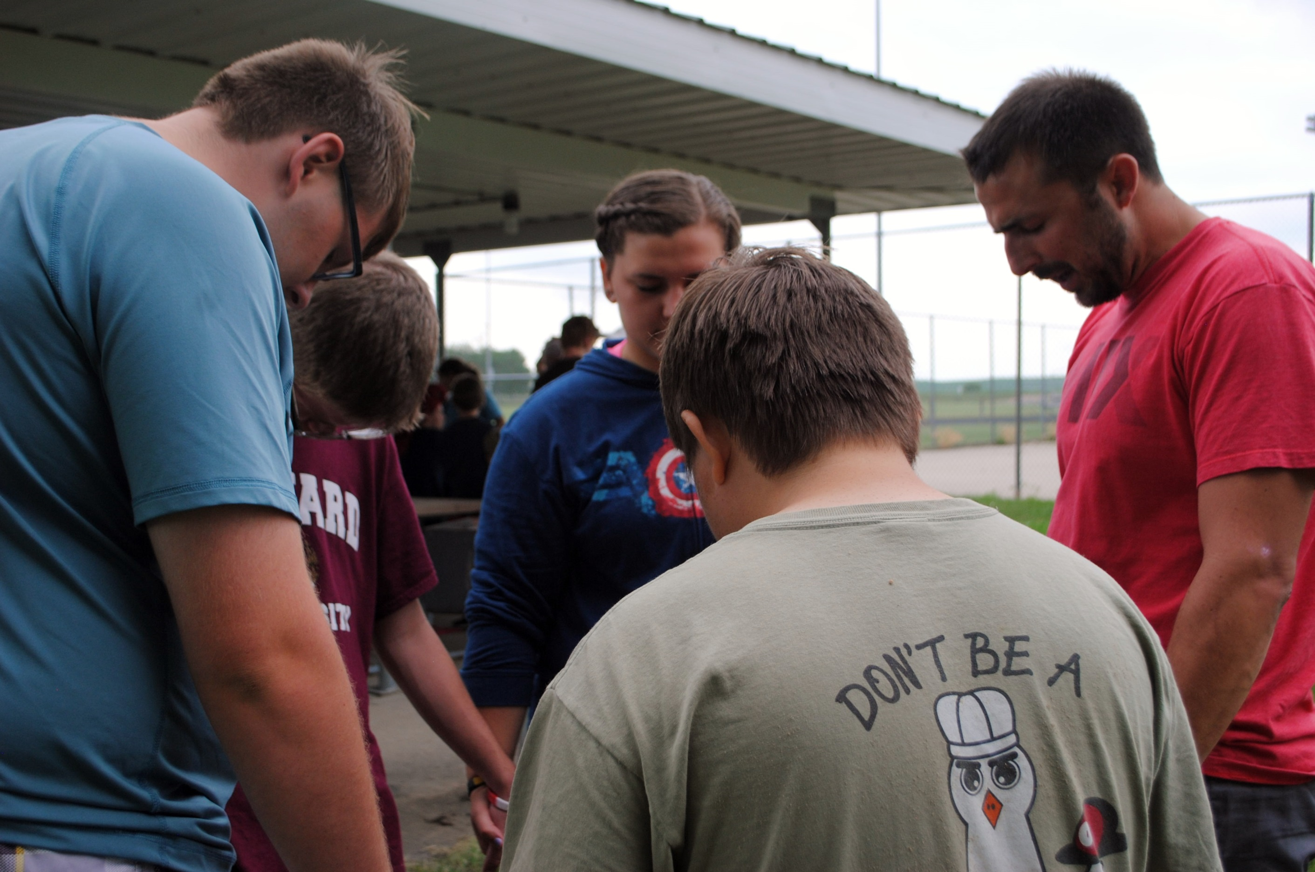

**“I press on toward the goal to win the prize for which God has called me heavenward in Christ Jesus”**

**Paul**

**“Pray also for me . . . that I may fearlessly make known the message of the Gospel**

**. . .”**

**Paul**